Grant Percentage Tracker Docs

Ariel Roane

Biomedical Informatics and Biostatistics Intern

Summer ‘17

Table of Contents

Database Design 2

MySQL Conceptual/Logical 2

Website Procedures 2

# Database Design

## MySQL Conceptual/Logical

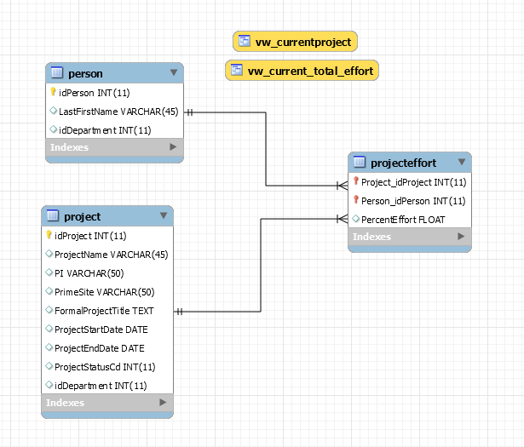

**Tables and View Descriptions**

## MySQL Physical

**Users and Privileges**

**Functions and Stored Procedures**

**Functions:**

Get_effort2 – function to return the float value of a sum of percent efforts that a person has across projects in a certain date range

Get_projects – function to return a comma separated list of projects that a person has within a certain date range

**Stored Procedures:**

Sp_insert_rel- stored procedure to insert relationship between a project and a person (insert a record into the percenteffort table)

Sp_person_info – selects all project information for a person

Sp_project_info – selects all person information for a project

Sp_remove_record – removes a record from the projecteffort table, thus removing a relationship between a person and a project. If the relationship is the last one that exists with a specific project, that project is removed

Sp_test_input – generates a year from date table of percent efforts for a person based on a date and percentage, uses temporary tables so can be used for testing

# Website Procedures